Task 1

1. Download Git from here https://git-scm.com/ (Version 2.26.2)

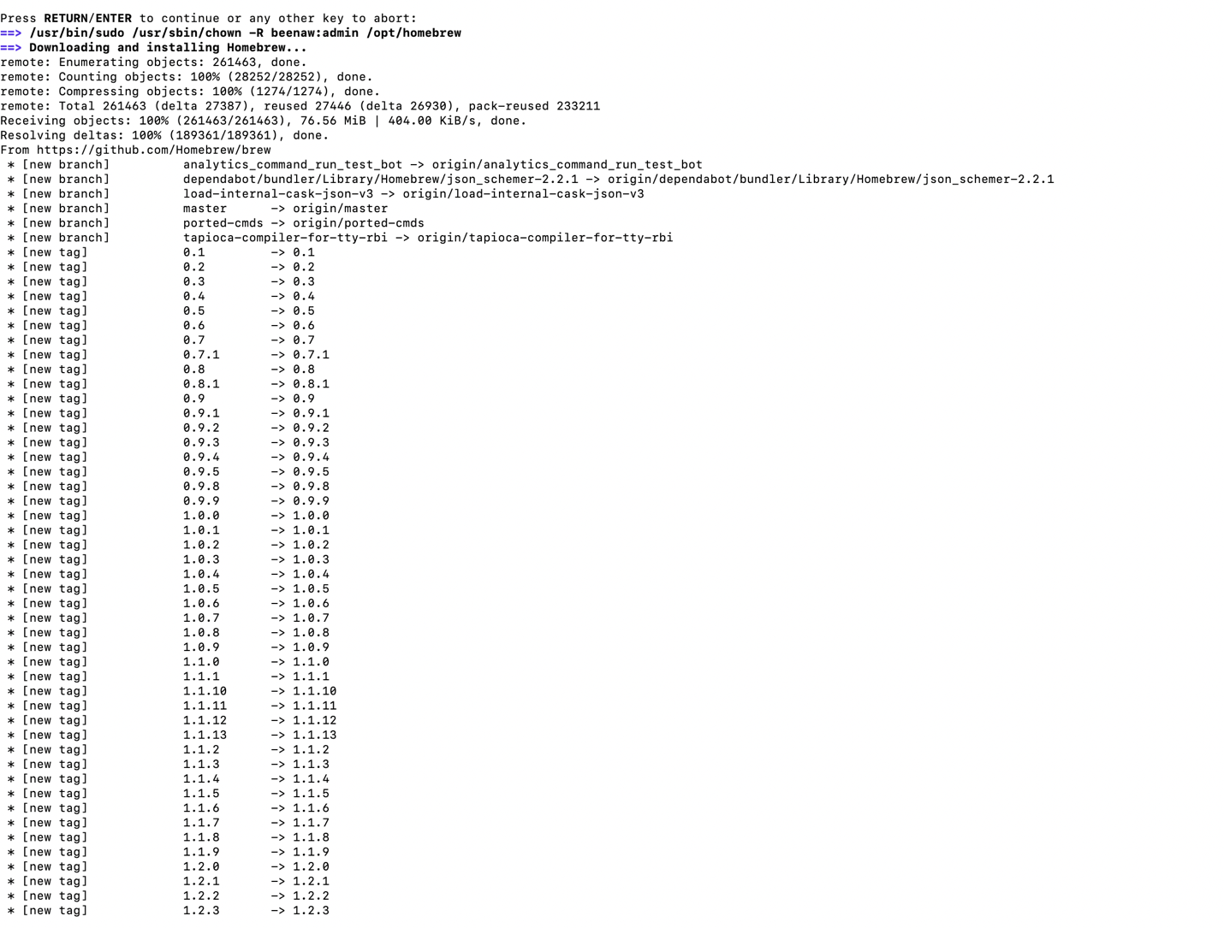

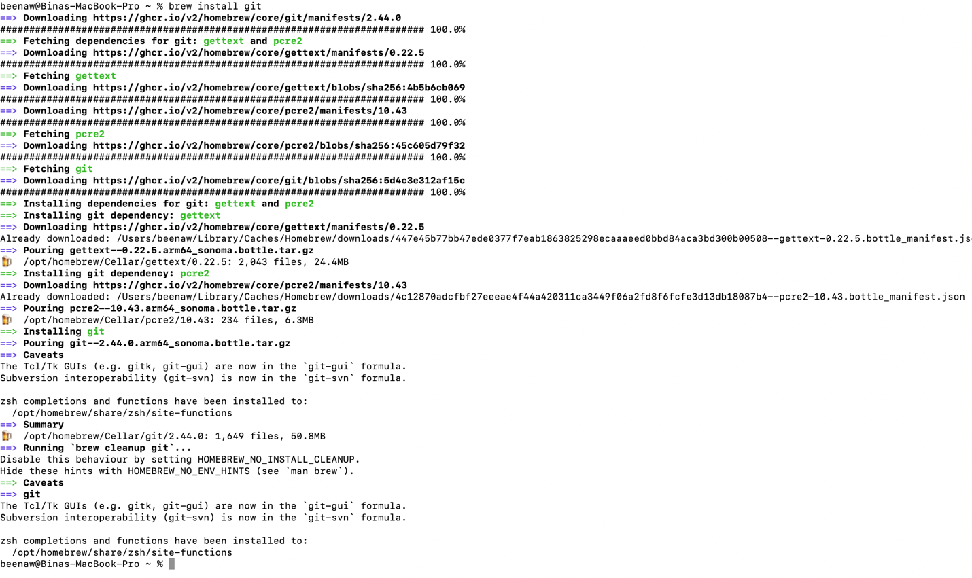

2. Install Git (Installation Guide: https://www.youtube.com/watch?v=SWYqp7iY_Tc)

3. Create a Folder in Desktop with name “L3” and Right Click on folder L3 and Select Git

Bash Here. You will see this screen

4. Check git version

* git –version



5. Now add files with this Command:

* touch index.html
* touch about.html
* touch resources.txt



6. Check your Folder, you will see these files

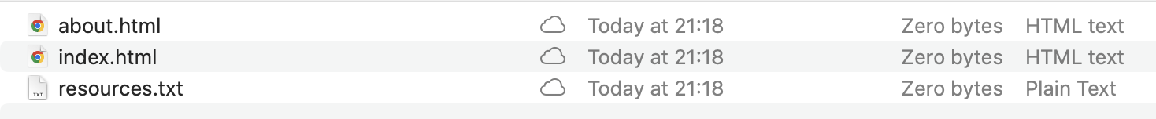

7. Open your file index.html in notepad or notepad++. Add these lines of code & save

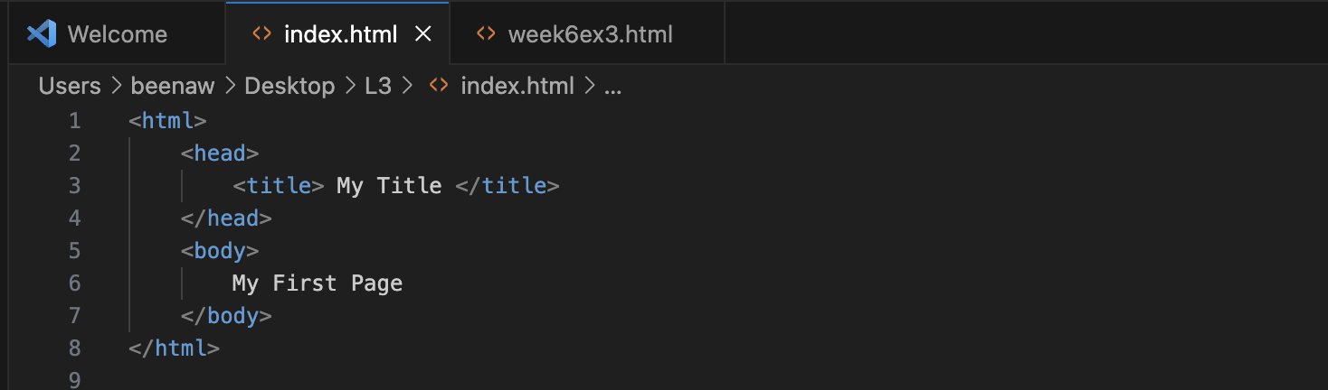

8. Open resources.txt and Write your name and Save this file

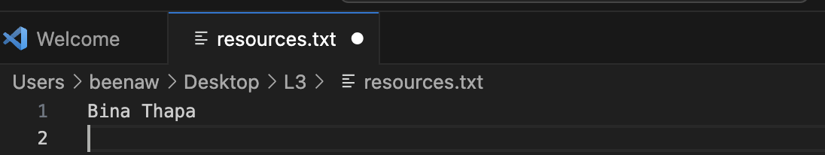

9. Initialize a Git repository/working directory

* git init
* Check your Folder, you will see .git folder. And within this folder you will find

Git Related Folders and files.

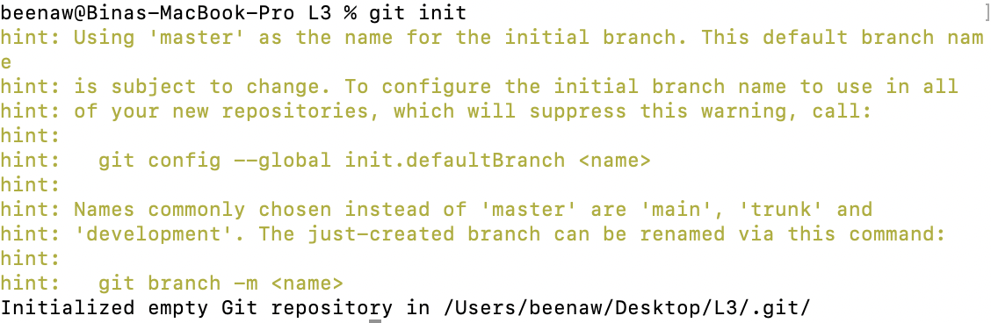

10. Configure user name and email

* git config --global user.name ‘Your Name’
* git config --global user.email ‘youremail@gmail.com’

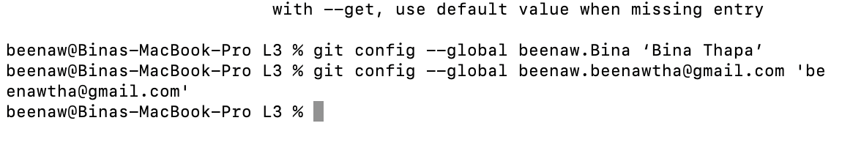

11. Check Status of Working directory

* git status

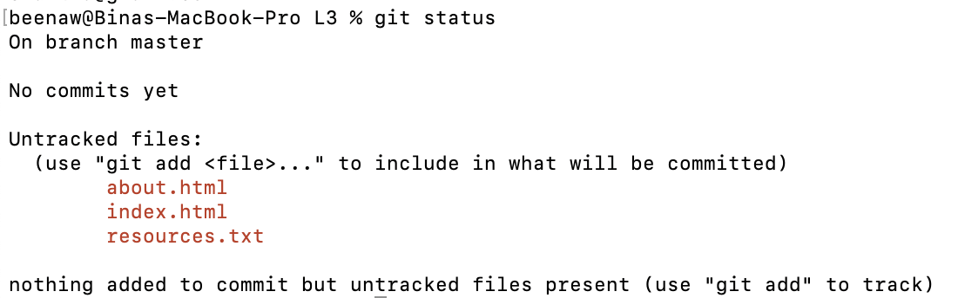

12. Add file or files

* git add index.html / git add .
* git add .



13. Check Status of Working directory

* git status

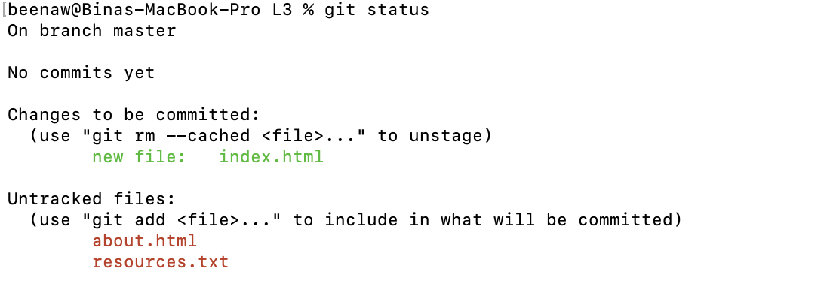

14. Commit chages in your working directory

* git commit
* git commit –m “Some git commit message”

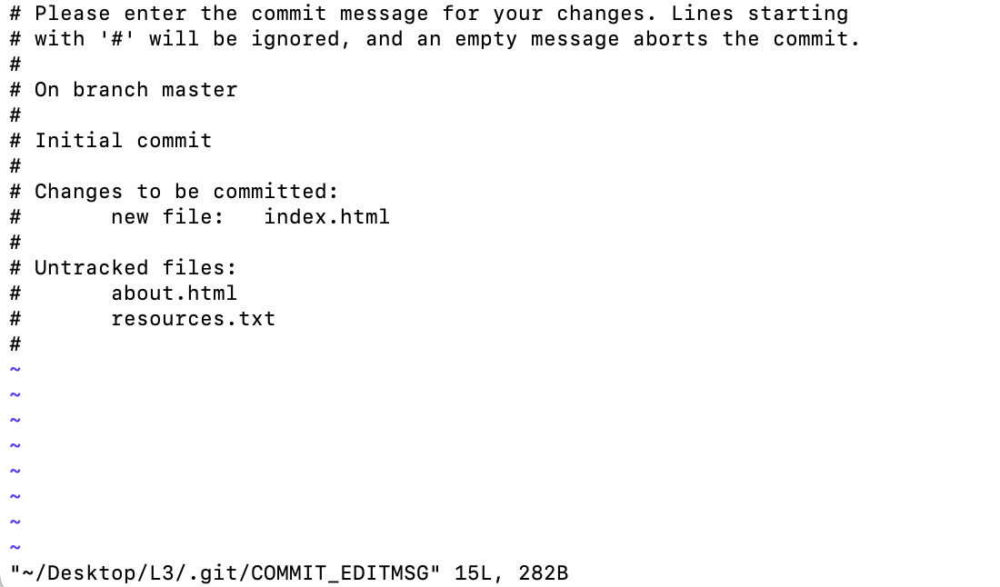

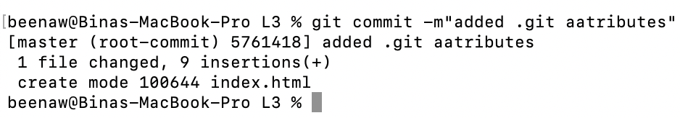

15. After all commit, Check Status of Working directory (This will show you message like

nothing to commit, working tree clean)

* git status

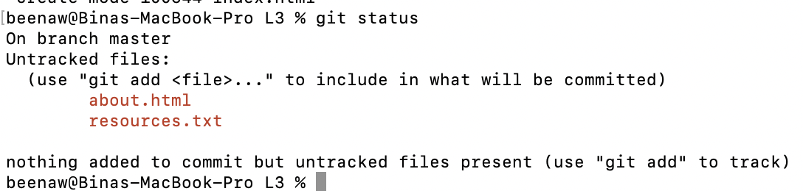

16. Make changes to resources.txt. Add few names of your friends

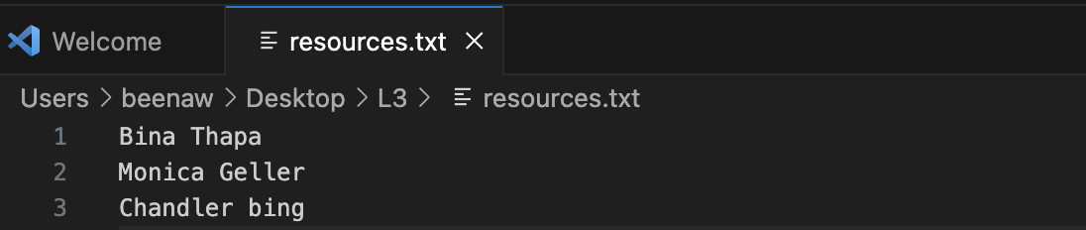

17. Check with git status, it will show (changes not staged for commit)

* git status

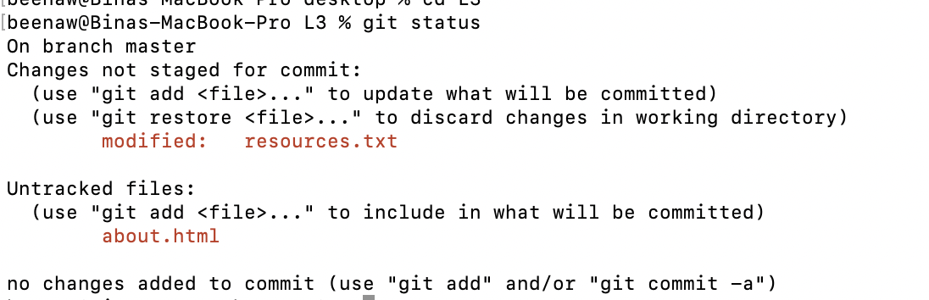

18. Add file or files

* git add .



19. Commit chages in your working directory with commit message

* git commit -m ‘Changed resouces.txt’

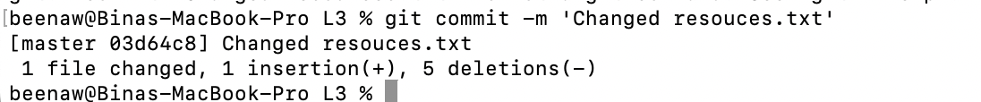

20. Check with git status, it will show (changes not staged for commit)

* git status

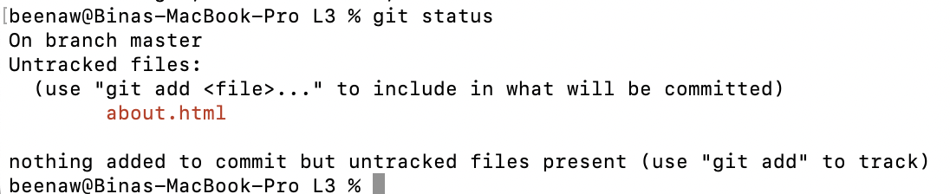

21. View commit history

* git log